**Chapter no 2-: System Model**

It has a design which implies to monitor the the parameters govern by the electroplating bath. By considering the problem definition given by the industry model has been designed. It has design features to achieve the objective as per suggested below

**Proposed feature to achieve the project objectives-:**

1. The very first aim is to detect the change in the parameters govern by the bath this parameters are

* PH and Temperature value of the electrolyte solution.
* Smoke gas and carbon monoxide within the bath environment

1. To compare those detected sensed values with the predefined standard value required for the bath
2. To obtain the wireless features in the project which will allow to send the collected data to the electroplating plant office(managers office).
3. To obtain the easy installation, flexible with hardware, compact system (system should be easily installed at another bath site)
4. To achieve the indication of change detected beyond the limited values of parameters
5. To achieve a user friendly hardware and software flexible system.

Therefore to achieve these specific objectives features the following block diagram has been design

**System model Block diagram-:**

The system model includes two parts

1. **Parameters measuring terminal-:** First part is at the actual electroplating bath site whose work is to measure the values and transmit it to the receiver site which is in the manager’s office. It consist of the following stages
2. **Transducers -:** in this block there are the different types of sensors which sensed the change in the values of electrolyte solution and bath environment and also convert them to the digital format compatible to the microcontroller.
3. PH sensor (SKU.SEN0161).
4. smoke gas sensor (Mq2)
5. carbon monoxide sensor (Mq7)
6. temperature sensor (DS18B20)
7. **Power supply -:** this block consist of the supply to the system as per the requirement of the microcontroller. It supply the arduino uno with **12V dc 1A**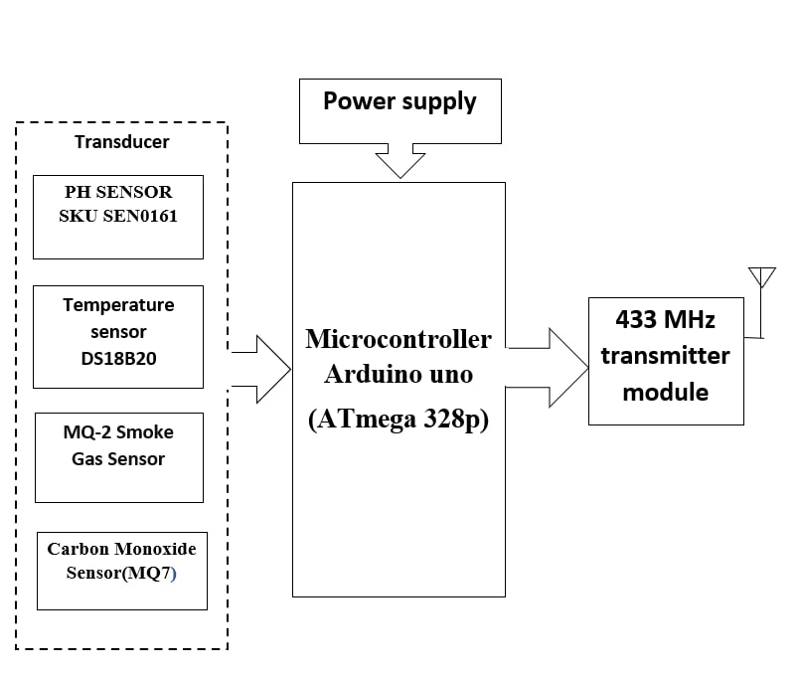 In the electroplating plant the bath itself has a attached varialble power supply so for supply requirement will be fulfilled directly by it. All the sensors are directly compatible with the arduino so supply for the sensors will be directly taken from the microcontroller (arduino uno)
8. **Microcontroller (arduino uno)-**: it uses the arduinoi unoi which has a AVR based controller Atmega 328p the micro controller is the heart of the proposed system. It continuously monitors the digitized parameters of the various sensors and verifies them with predefined threshold values and indicate through the buzzer if values change beyond the limits. It also assign the collected data to the transmitter module which in turns transmit it to the receiver section
9. **Transmitter module -**: Transmitter section gets the data from the controller and transmit it by arranging it in a frame with a ASK modulation technique.

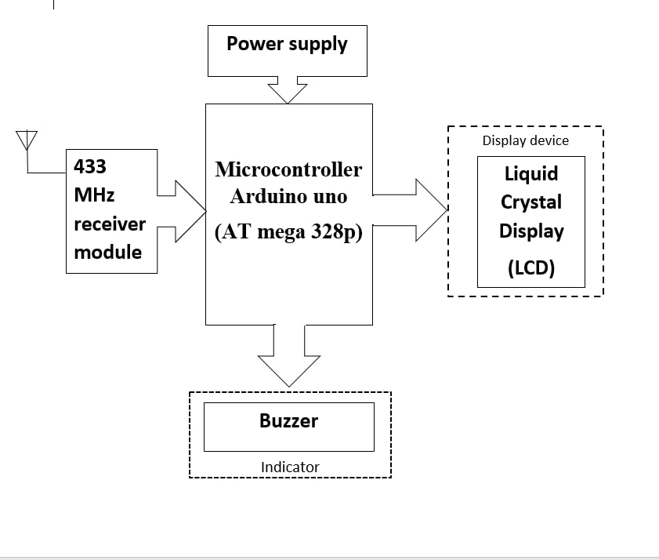

1. **Receiver and Display terminal -:** Second part which is located at the office receives the data and display it and in case if there is change in the values then indicating it. It consist of the following stages.
2. **Receiver module-:** receiver module receives the data transmitted by the transmitter section demodulate it and pass it to the controller
3. **Microcontroller (arduino uno) -:** it is the heart of the receiver section. It collect the received data and show it on the display. Also detect if the special command indicating the to enable buzzer received which in turn ahead sound the buzzer
4. **Power supply -**: it functions same as aboven given section of the power supply but here use of the 12V dc 1A adapter is used to power the arduino
5. **Display Unit -:** A Liquid Crystal Display(JHD204A) is used to indicate the present value of parameters. The data of the each sensor will be display one by one.
6. **Indicator device-:** Buzzer(KY-012) It is a small buzzer module to indicate the change in the parameters beyond the predefined limit of the parameters.